Business Process Modeled
The business process modeled is the point-of-sale (POS) transactions at the P&C grocery store chain. This includes capturing sales data from customer purchases at the checkout, such as item details, quantities, prices, and transaction metadata, to support basic sales analysis like total sales by product, store, date, or customer. It can help to address, for instance, what are total sales by product category per day? etc.

Grain of the Fact Table
The fact table is at the transaction line-item level (each row represents one product sold in a specific transaction). This is the most granular level for POS data, allowing aggregation up to transaction, day, store, or product levels. It's additive for measures like quantity and price, supporting detailed analysis without losing item-specific details.

Assumptions
- The receipt includes standard attributes like transaction ID, date and time, store details, item code, quantity, price, tax, etc.. Additional attributes such as product, category, brand, are assumed based on typical grocery point-of-sale (POS) systems and dimensional modeling.
- The receipt also captures customer information which supports a customer dimension.
- And, in general, promotions, discounts, or coupons should be considered at the item level to enable analysis of promotional impacts on sales.
- Product hierarchies and store hierarchies in the source system should also be considered for richer analysis.

Questions for the P&C Executives
- What customer information can be captured at the POS and how it can be handled for transactions?
- How product attributes are stored in the POS which might not show on the receipt that enhance the sales analysis?
- Could the POS support split payments of transactions, and if so, how could this be modeled?
- How are promotions tracked in the POS at the transaction level, line-item level, or both and what attributes are available? Like promotion type and duration?

Dimensional Data Model
- Surrogate keys (PK): Integer-based primary keys in dimensions for performance and handling slowly changing dimensions (SCDs).
- Natural keys (NK): Business identifiers.
- Foreign keys (FK): In the fact table linking to dimension PKs (one-to-many relationships).
- Hierarchies: In dimensions (e.g., Date: year > quarter > month; Product: category > subcategory).
- Degenerate dimensions: Transaction_ID and Line_Number stored directly in the fact (low cardinality, no full dimension needed).
- xMeasures: Additive facts (e.g., quantity_sold) derived from receipt lines (e.g., extended_price = quantity_sold * unit_price).
- Attributes are based on typical receipt elements and extended with logical additions for analysis (justified in assumptions).

The diagram does not show all attribute names since it is too messy, instead, I put all of them in tables (Fact and Dimension) after the model to complement.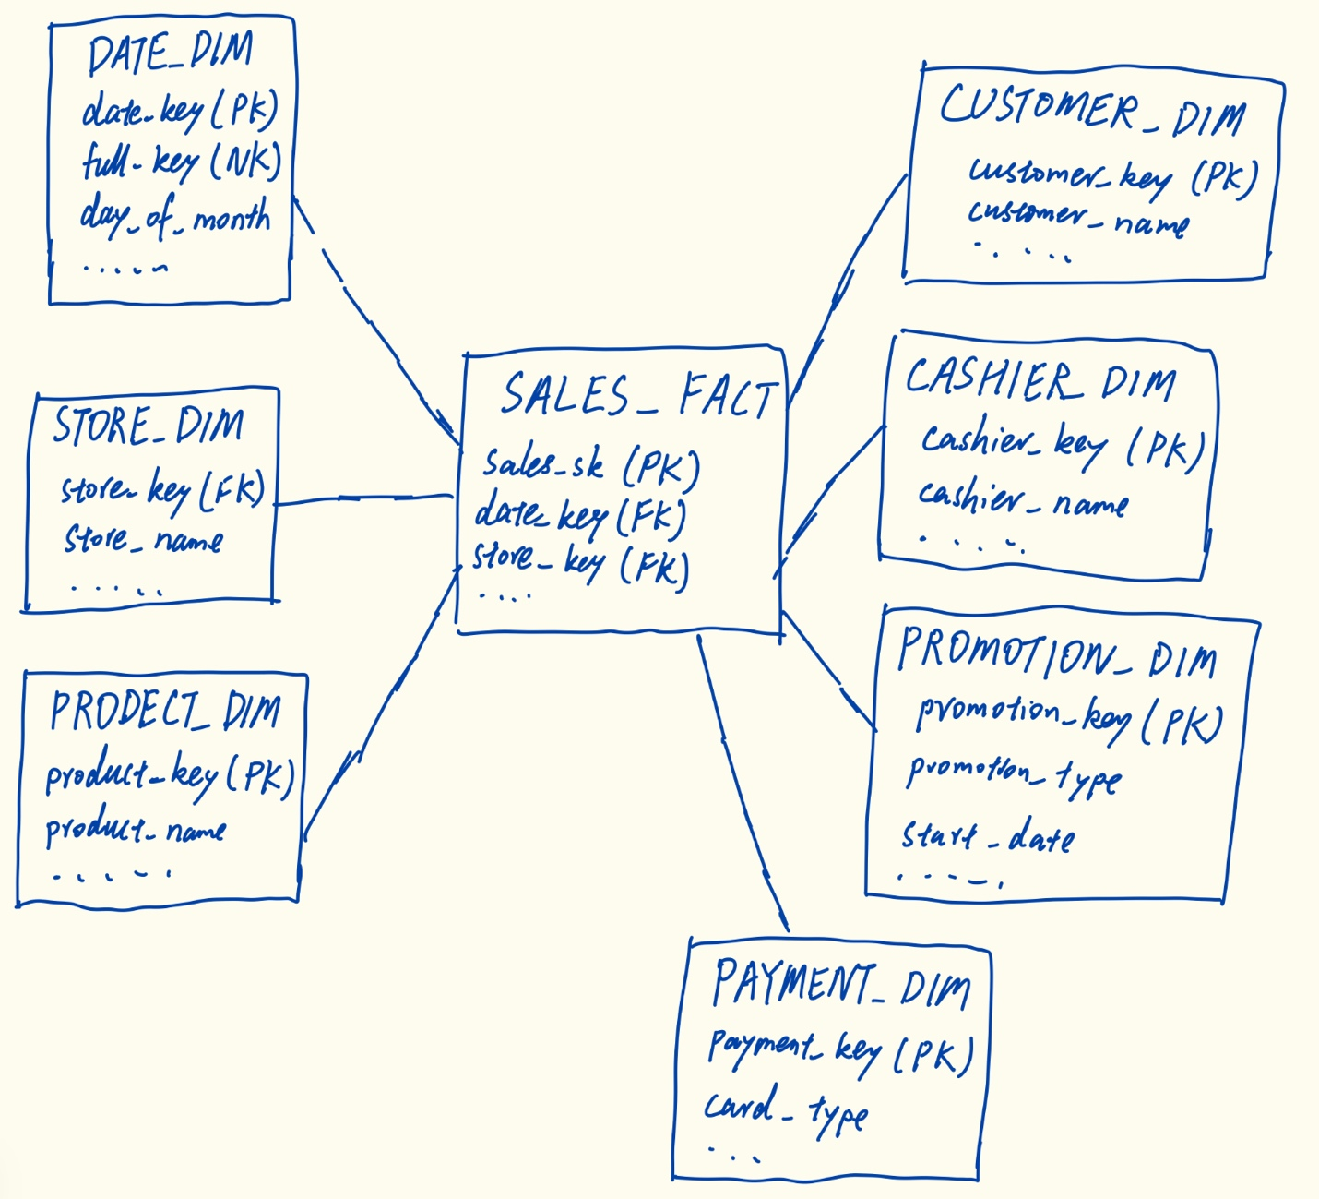

SALES_FACT (Fact Table)
Column Name | Type/Role | Description
sales_sk | PK | Unique surrogate key for each fact row.
date_key | FK | References DATE_DIM.
store_key | FK | References STORE_DIM.
product_key | FK | References PRODUCT_DIM.
customer_key | FK | References CUSTOMER_DIM.
cashier_key | FK | References CASHIER_DIM.
promotion_key | FK | References PROMOTION_DIM.
Payment_key | FK | References PAYMENT_DIM.
transaction_id | NK | Operational transaction number from the receipt.
line_item_number | NK | Sequence number for the line item on the receipt.
quantity_sold | Measure | Number of units sold.
unit_price | Measure | Price per unit from the receipt.
extended_price | Measure | Quantity * unit_price (line total before discount).
discount_amount | Measure | Any discount applied to the line item.
tax_amount | Measure | Tax for the line item.
net_amount | Measure | Extended price minus discount plus tax.

DATE_DIM (Dimension Table)
Column Name | Type/Role | Description
date_key | PK | Unique surrogate key.
full_date | NK | Actual date.
day_of_month | Attribute | Day number.
day_of_week | Attribute | Weekday name.
month_name | Attribute | Month name.
quarter | Attribute | Quarter number.
year | Attribute | Year.
is_holiday | Attribute | Flag for holiday (Y/N).
fiscal_year | Attribute | Fiscal year (assumed calendar match).

STORE_DIM (Dimension Table)
Column Name | Type/Role | Description
store_key | PK | Unique surrogate key.
store_number | NK | Store ID from POS system.
store_name | Attribute | Name.
address | Attribute | Street address.
city | Attribute | City.
state | Attribute | State.
zip_code | Attribute | ZIP code.
phone_number | Attribute | Store phone.
manager_name | Attribute | Store manager.
open_date | Attribute | Date store opened.
region | Attribute | Geographic region (assumed hierarchy).

PRODUCT_DIM (Dimension Table)
Column Name | Type/Role | Description
product_key | PK | Unique surrogate key.
sku | NK | Stock keeping unit/code from receipt.
product_name | Attribute | Name.
brand_name | Attribute | Brand.
category | Attribute | Product category.
sub_category | Attribute | Subcategory.
package_size | Attribute | Size.
unit_cost | Attribute | Cost to store (for margin analysis).
shelf_life_days | Attribute | Days until expiration.
is_perishable | Attribute | Flag for perishable items (Y/N).

CUSTOMER_DIM (Dimension Table)
Column Name | Type/Role | Description
customer_key | PK | Unique surrogate key.
customer_id | NK | Loyalty card or customer number.
customer_name | Attribute | Full name.
address | Attribute | Home address.
city | Attribute | City.
state | Attribute | State.
zip_code | Attribute | ZIP code.
phone_number | Attribute | Phone.
email | Attribute | Email address.
join_date | Attribute | Date joined loyalty program.
customer_segment | Attribute | Segment (e.g., Frequent Shopper; assumed).

CASHIER_DIM (Dimension Table)
Column Name | Type/Role | Description
cashier_key | PK | Unique surrogate key.
cashier_id | NK | Employee ID from POS.
cashier_name | Attribute | Full name.
hire_date | Attribute | Date hired.
position | Attribute | Role (e.g., Cashier, Supervisor).
department | Attribute | Department.

PROMOTION_DIM (Dimension Table)
Column Name | Type/Role | Description
promotion_key | PK | Unique surrogate key.
promotion_id | NK | Promotion code from POS.
promotion_name | Attribute | Name.
promotion_type | Attribute | Type.
discount_percent | Attribute | Percentage off.
start_date | Attribute | Promotion start date.
end_date | Attribute | Promotion end date.
media_type | Attribute | Advertising method.

PAYMENT_DIM (Dimension Table)
Column Name | Type/Role | Description
payment_key | PK | Unique surrogate key.
payment_method_id | NK | Code from POS.
payment_method_name | Attribute | e.g., Cash, Credit Card, Debit.
card_type | Attribute | e.g., Visa, Mastercard (if applicable).

